CHAPTER 2 – TRANSFORMERS

Summary:

- Types and Construction of Transformers

- The Ideal Transformer
- Power in an Ideal Transformer
- Impedance transformation through a transformer
- Analysis of circuits containing ideal transformer

- Theory of operation of real single-phase transformers.
  - The voltage ratio across a transformer
  - The magnetization current in a Real Transformer
  - The current ratio on a transformer and the Dot Convention

- The Equivalent Circuit of a Transformer.
    - Exact equivalent circuit
    - Approximate equivalent circuit
    - Determining the values pf components in the transformer model

- The Per-Unit System of Measurement

- Transformer voltage regulation and efficiency
    - The transformer phasor diagram
    - Transformer efficiency

- Three phase transformers

1. Types and Construction of Transformers

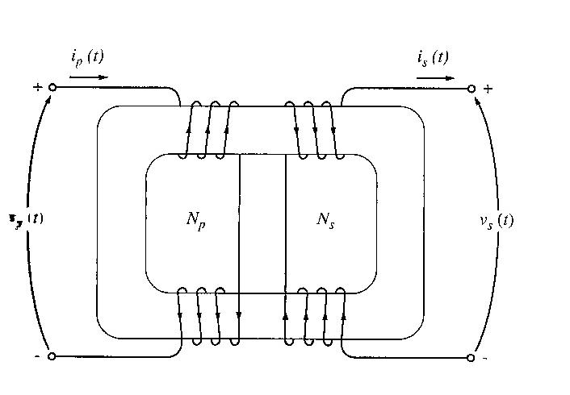
Types of cores for power transformer (both types are constructed from thin laminations electrically isolated from each other – minimize eddy currents)

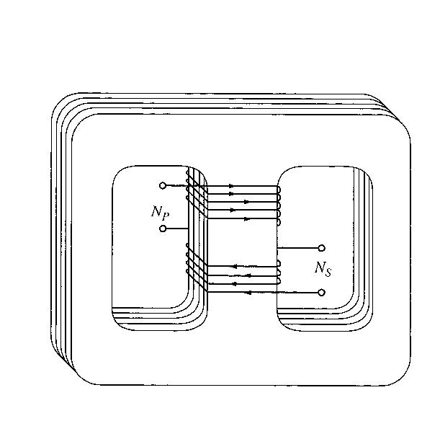
- Core Form : a simple rectangular laminated piece of steel with the transformer windings wrapped around two sides of the rectangle.

- Shell Form : a three legged laminated core with the windings wrapped around the centre leg.

The primary and secondary windings are wrapped one on top of the other with the low-voltage winding innermost, due to 2 purposes:

- It simplifies the problem of insulating the high-voltage winding from the core.
- It results in much less leakage flux

Types of transformers:

- Step up/Unit transformers – Usually located at the output of a generator. Its function is to step up the voltage level so that transmission of power is possible.
- Step down/Substation transformers – Located at main distribution or secondary level transmission substations. Its function is to lower the voltage levels for distribution 1st level purposes.
- Distribution Transformers – located at small distribution substation. It lowers the voltage levels for 2nd level distribution purposes.
- Special Purpose Transformers - E.g. Potential Transformer (PT) , Current Transformer (CT)

2. The Ideal Transformer

- Definition – a lossless device with an input winding and an output winding.

- Figures below show an ideal transformer and schematic symbols of a transformer.
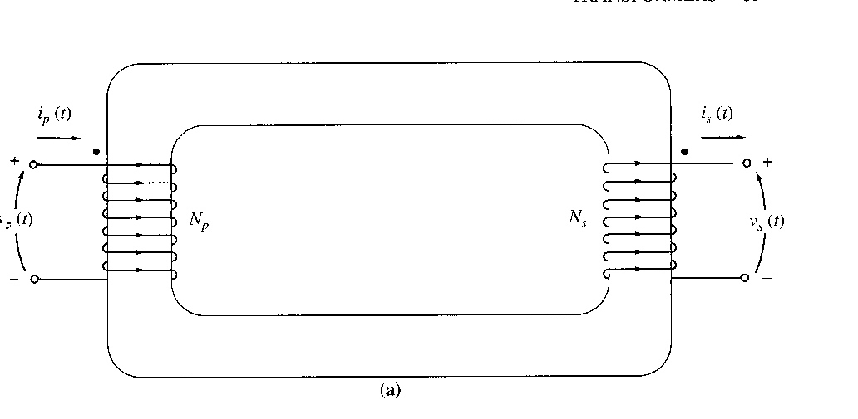
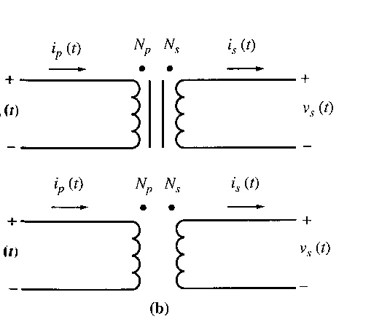

- The transformer has N_{p} turns of wire on its primary side and N_{s} turns of wire on its secondary sides. The relationship between the primary and secondary voltage is as follows:
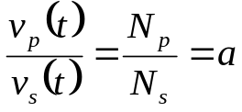

where a is the turns ratio of the transformer.

- The relationship between primary and secondary current is:

N_{p} i_{p} (t) = N_{s} i_{s} (t)
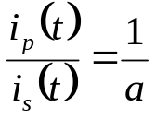

- Note that since both type of relations gives a constant ratio, hence the transformer only changes ONLY the magnitude value of current and voltage. Phase angles are not affected.

- The dot convention in schematic diagram for transformers has the following relationship:

  - If the primary voltage is +ve at the dotted end of the winding wrt the undotted end, then the secondary voltage will be positive at the dotted end also. Voltage polarities are the same wrt the dots on each side of the core.

  - If the primary current of the transformer flows into the dotted end of the primary winding, the secondary current will flow out of the dotted end of the secondary winding.

Power in an Ideal Transformer

- The power supplied to the transformer by the primary circuit:

P_{in} = V_{p} I_{p} cos θ_{p}

Where θ_{p} = the angle between the primary voltage and the primary current. The power supplied by the transformer secondary circuit to its loads is given by:

P_{out} = V_{s} I_{s} cos θ_{s}

Where θ_{s} = the angle between the secondary voltage and the secondary current.

- The primary and secondary windings of an ideal transformer have the SAME power factor – because voltage and current angles are unaffected θ_{p} - θ_{s} = θ

- How does power going into the primary circuit compare to the power coming out?

P_{out} = V_{s} I_{s} cos θ

Also, V_{s} = V_{p}/a and I_{s} = a I_{p}
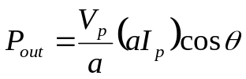

So,

P_{out} = V_{p} I_{p} cos θ = P_{in}

The same idea can be applied for reactive power Q and apparent power S.

Output power = Input power

Impedance Transformation through a Transformer

- The impedance of a device or an element is defined as the ratio of the phasor voltage across it to the phasor current flowing through it:
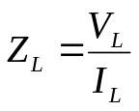

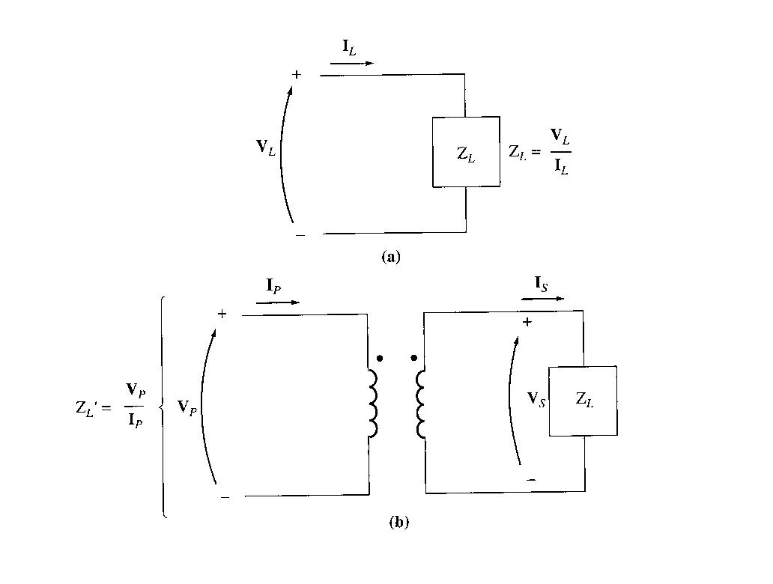
- Definition of impedance and impedance scaling through a transformer:

- 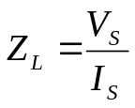Hence, the impedance of the load is:

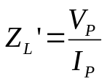
- The apparent impedance of the primary circuit of the transformer is:

- Since primary voltage can be expressed as V_{P}=aV_{S}, and primary current as I_{P}=I_{S}/a, thus the apparent impedance of the primary is
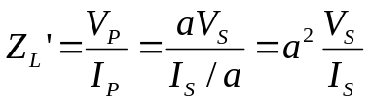

Z_{L}’ = a² Z_{L}

Analysis of Circuits containing Ideal Transformers

The easiest way for circuit analysis that has a transformer incorporated is by simplifying the transformer into an equivalent circuit.

Example 2.1

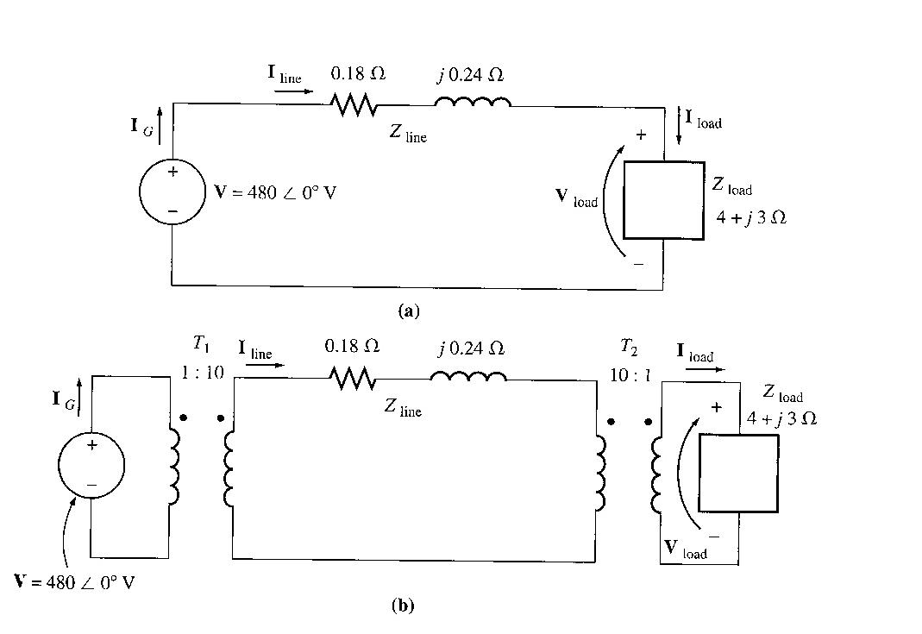
A generator rated at 480V, 60 Hz is connected a transmission line with an impedance of 0.18+j0.24Ω. At the end of the transmission line there is a load of 4+j3Ω.

      - If the power system is exactly as described above in Figure (a), what will the voltage at the load be? What will the transmission line losses be?
      - Suppose a 1:10 step-up transformer is placed at the generator end of the transmission line and a 10:1 step-down transformer is placed at the load end of the line (Figure (b)). What will the load voltage be now? What will the transmission line losses be now?

3. Theory of Operation of Real Single-Phase Transformers

Ideal transformers may never exist due to the fact that there are losses associated to the operation of transformers. Hence there is a need to actually look into losses and calculation of real single phase transformers.

Assume that there is a transformer with its primary windings connected to a varying single phase voltage supply, and the output is open circuit.

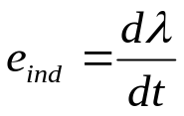Right after we activate the power supply, flux will be generated in the primary coils, based upon Faraday’s law,

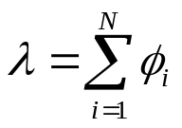where λ is the flux linkage in the coil across which the voltage is being induced. The flux linkage λ is the sum of the flux passing through each turn in the coil added over all the turns of the coil.

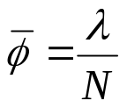This relation is true provided on the assumption that the flux induced at each turn is at the same magnitude and direction. But in reality, the flux value at each turn may vary due to the position of the coil it self, at certain positions, there may be a higher flux level due to combination of other flux from other turns of the primary winding.

Hence the most suitable approach is to actually average the flux level as
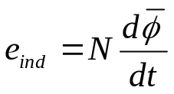

Hence Faraday’s law may be rewritten as:

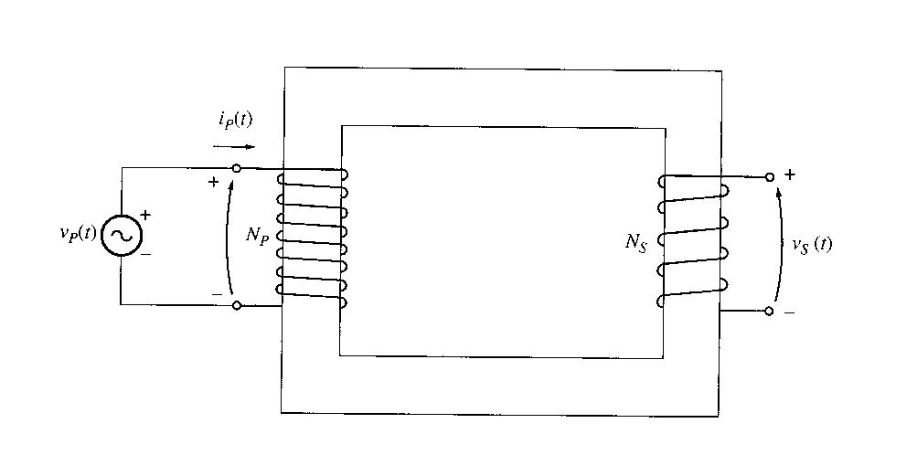
The voltage ratio across a Transformer

f the voltage source is v_{p}(t), how will the transformer react to this applied voltage?
Based upon Faraday’s Law, looking at the primary side of the transformer, we can determine the average flux level based upon the number of turns; where,

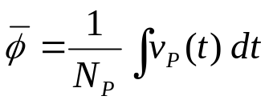

This relation means that the average flux at the primary winding is proportional to the voltage level at the primary side divided by the number of turns at the primary winding. This generated flux will travel to the secondary side hence inducing potential across the secondary terminal.

For an ideal transformer, we assume that 100% of flux would travel to the secondary windings. However, in reality, there are flux which does not reach the secondary coil, in this case the flux leaks out of the transformer core into the surrounding. This leak is termed as flux leakage.

Taking into account the leakage flux, the flux that reaches the secondary side is termed as mutual flux.

Looking at the secondary side, there are similar division of flux; hence the overall picture of flux flow may be seen as below:

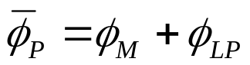Primary Side:

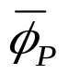 = total average primary flux
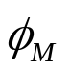 = flux component linking both rpimary and secondary coils
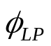 = primary leakage flux

For the secondary side, similar division applies.

Hence, looking back at Faraday’s Law,
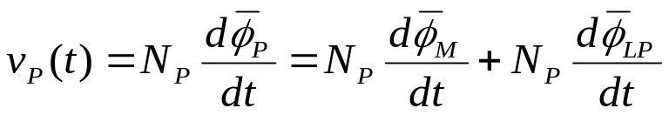

Or this equation may be rewritten into:

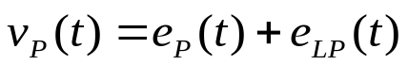

The same may be written for the secondary voltage.

The primary voltage due to the mutual flux is given by
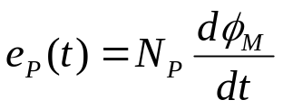

And the same goes for the secondary (just replace ‘P’ with ‘S’)

From these two relationships (primary and secondary voltage), we have
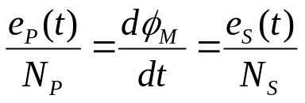

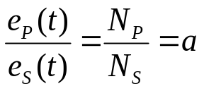
Therefore,

Magnetization Current in a Real transformer

Although the output of the transformer is open circuit, there will still be current flow in the primary windings. The current components may be divided into 2 components:

- Magnetization current, i_{M} – current required to produce flux in the core.
- Core-loss current, i_{h+e} – current required to compensate hysteresis and eddy current losses.

We know that the relation between current and flux is proportional since,

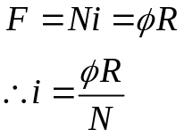

Therefore, in theory, if the flux produce in core is sinusoidal, therefore the current should also be a perfect sinusoidal. Unfortunately, this is not true since the transformer will reach to a state of near saturation at the top of the flux cycle. Hence at this point, more current is required to produce a certain amount of flux.

If the values of current required to produce a given flux are compared to the flux in the core at different times, it is possible to construct a sketch of the magnetization current in the winding on the core. This is shown below:
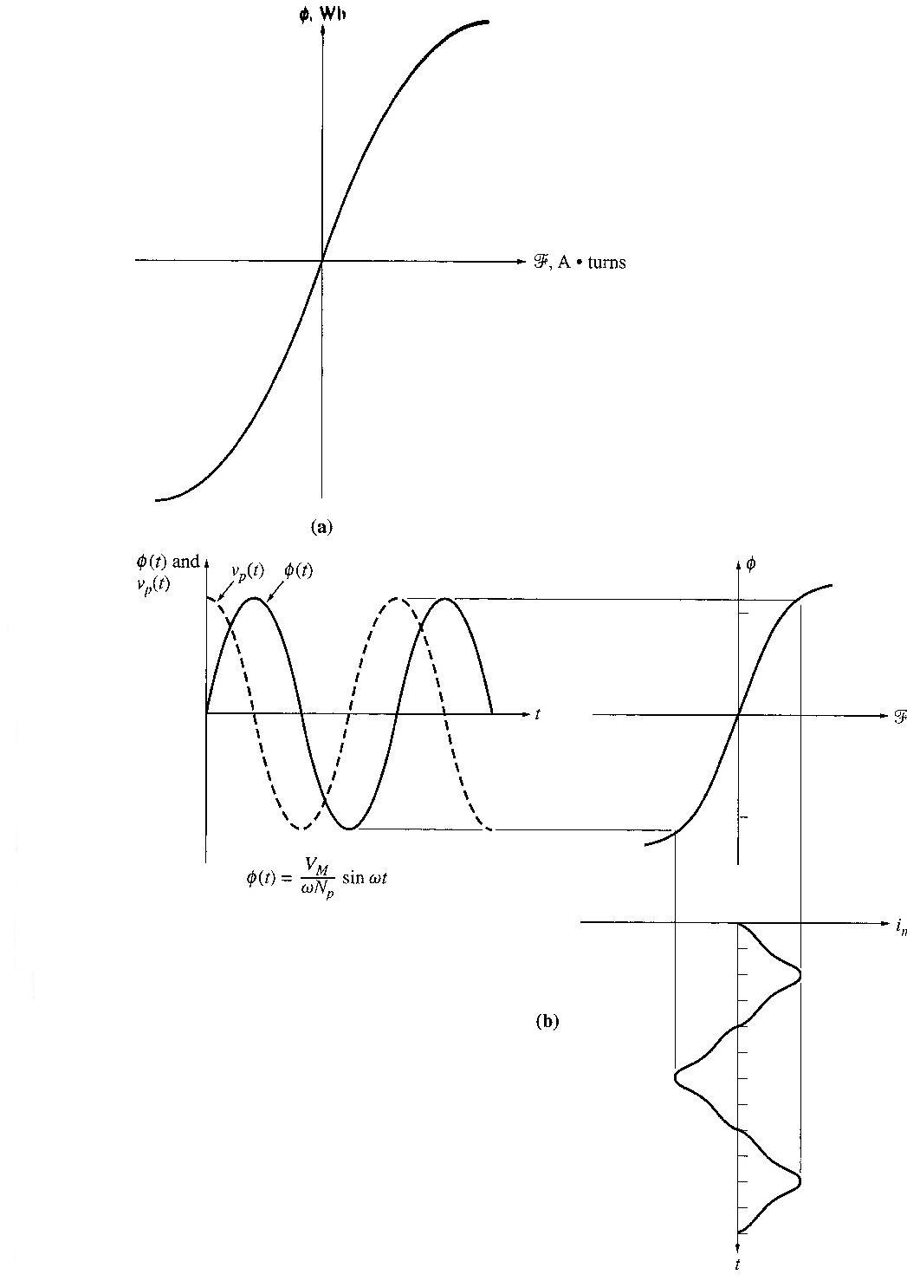

Hence we can say that current in a transformer has the following characteristics:

- It is not sinusoidal but a combination of high frequency oscillation on top of the fundamental frequency due to magnetic saturation.
- The current lags the voltage at 90º
- At saturation, the high frequency components will be extreme as such that harmonic problems will occur.

Looking at the core-loss current, it again is dependent upon hysteresis and eddy current flow. Since Eddy current is dependent upon the rate of change of flux, hence we can also say that the core-loss current is greater as the alternating flux goes past the 0 Wb. Therefore the core-loss current has the following characteristics:

- When flux is at 0Wb, core-loss current is at a maximum hence it is in phase with the voltage applied at the primary windings.
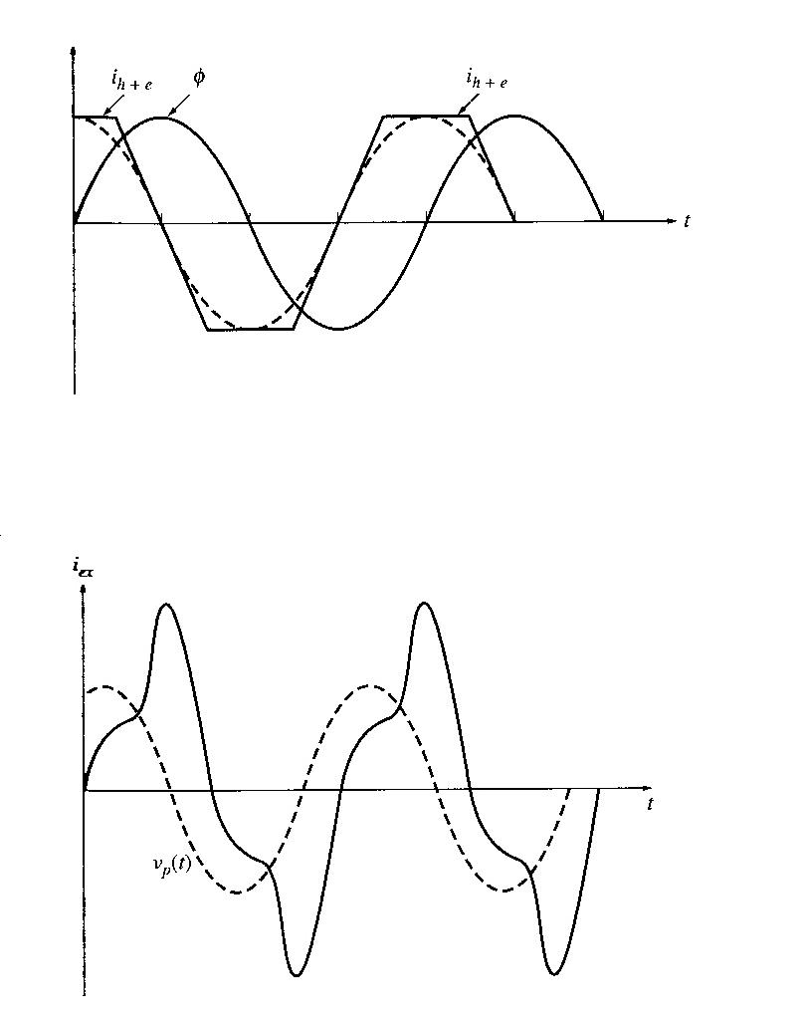
- Core-loss current is non-linear due to the non-linearity effects of hysteresis.

Now since that the transformer is not connected to any load, we can say that the total current flow into the primary windings is known as the excitation current.

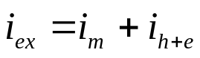

Current Ratio on a Transformer and the Dot Convention.

Now, a load is connected to the secondary of the transformer.
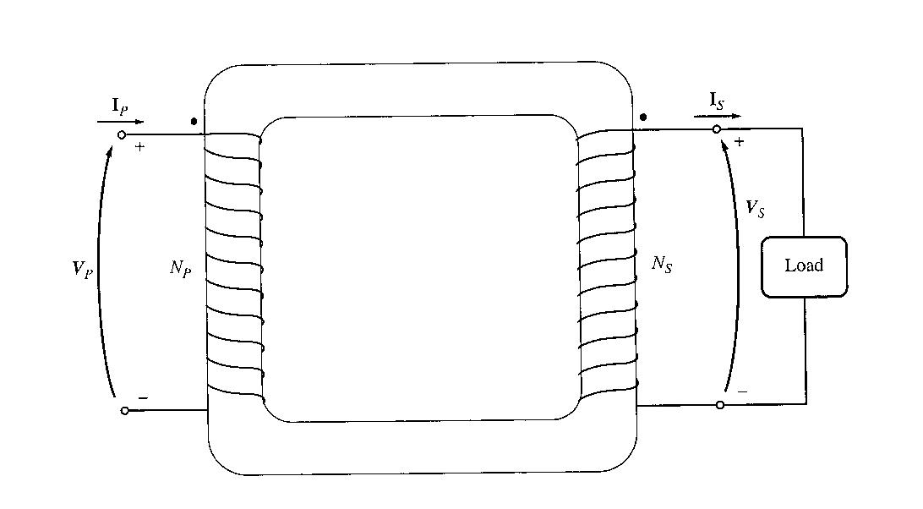

The dots help determine the polarity of the voltages and currents in the core withot having to examine physically the windings.

A current flowing into the dotted end of a winding produces a positive magnetomotive force, while a current flowing into the undotted end of a winding produces a negative magnetomotive force.

In the figure above, the net magnetomotive force is F_{net} = N_{P}i_{P} - N_{S}i_{S}

This net magnetomotive force must produce the net flux in the core, so

F_{net} = N_{P}i_{P} - N_{S}i_{S} = R

Where R is the reluctance of the core. The relationship between primary and secondary current is approx

F_{net} = N_{P}i_{P} - N_{S}i_{S} ≈ 0 as long as the core is unsaturated.

Thus,

N_{P}i_{P} ≈ N_{S}i_{S}

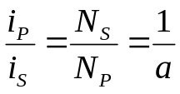

In order for the magnetomotive force to be nearly zero, current must flow into one dotted end and out of the other dotted end.

As a conclusion, the major differences between an ideal and real transformer are as follows:

- An ideal transformer’s core does not have any hysteresis and eddy current losses.
- The magnetization curve of an ideal transformer is similar to a step function and the net mmf is zero.
- Flux in an ideal transformer stays in the core and hence leakage flux is zero.
- The resistance of windings in an ideal transformer is zero.

4. The equivalent circuit of a transformer

Taking into account real transformer, there are several losses that has to be taken into account in order to accurately model the transformer, namely:

- Copper (I²R) Losses – Resistive heating losses in the primary and secondary windings of the transformer.
- Eddy current Losses – resistive heating losses in the core of the transformer. They are proportional to the square of the voltage applied to the transformer.
- Hysteresis Losses – these are associated with the rearrangement of the magnetic domains in the core during each half-cycle. They are complex, non-linear function of the voltage applied to the transformer.
- 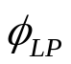Leakage flux – The fluxes and which escape the core and pass through only one of the transformer windings are leakage fluxes. They then produced self-inductance in the primary and secondary coils.

The exact equivalent circuit of a real transformer

The Exact equivalent circuit will take into account all the major imperfections in real transformer.

- Copper loss

They are modeled by placing a resistor R_{P} in the primary circuit and a resistor R_{S} in the secondary circuit.

ii) Leakage flux

As explained before, the leakage flux in the primary and secondary windings produces a voltage given by:
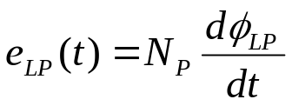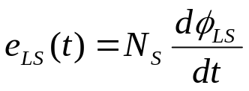

Since flux is directly proportional to current flow, therefore we can assume that leakage flux is also proportional to current flow in the primary and secondary windings. The following may represent this proportionality:
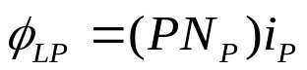

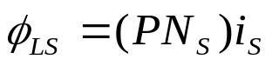

Where P = permeance of flux path
N_{P} = number of turns on primary coils
N_{S} = number of turns on secondary coils

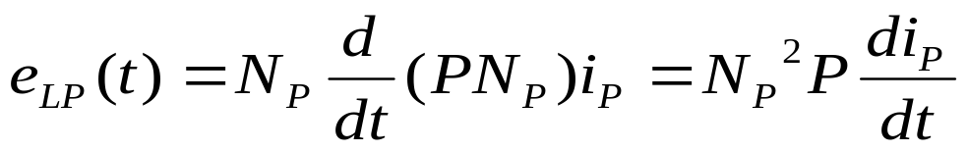Thus,

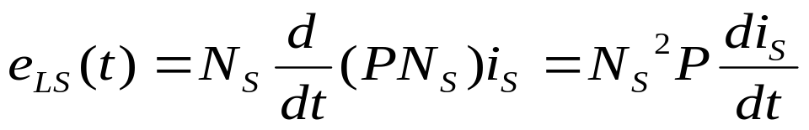

The constants in these equations can be lumped together. Then,
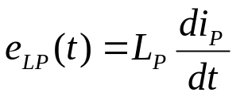

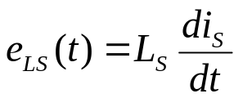

Where L_{P} = N_{P}² P is the self-inductance of the primary coil and L_{S} = N_{S}² P is the self-inductance of the secondary coil.

Therefore the leakage element may be modelled as an inductance connected together in series with the primary and secondary circuit respectively.

iii) Core excitation effects – magnetization current and hysteresis & eddy current losses

The magnetization current i_{m} is a current proportional (in the unsaturated region) to the voltage applied to the core and lagging the applied voltage by 90° - modeled as reactance X_{m} across the primary voltage source.

The core loss current i_{h+e} is a current proportional to the voltage applied to the core that is in phase with the applied voltage – modeled as a resistance R_{C} across the primary voltage source.

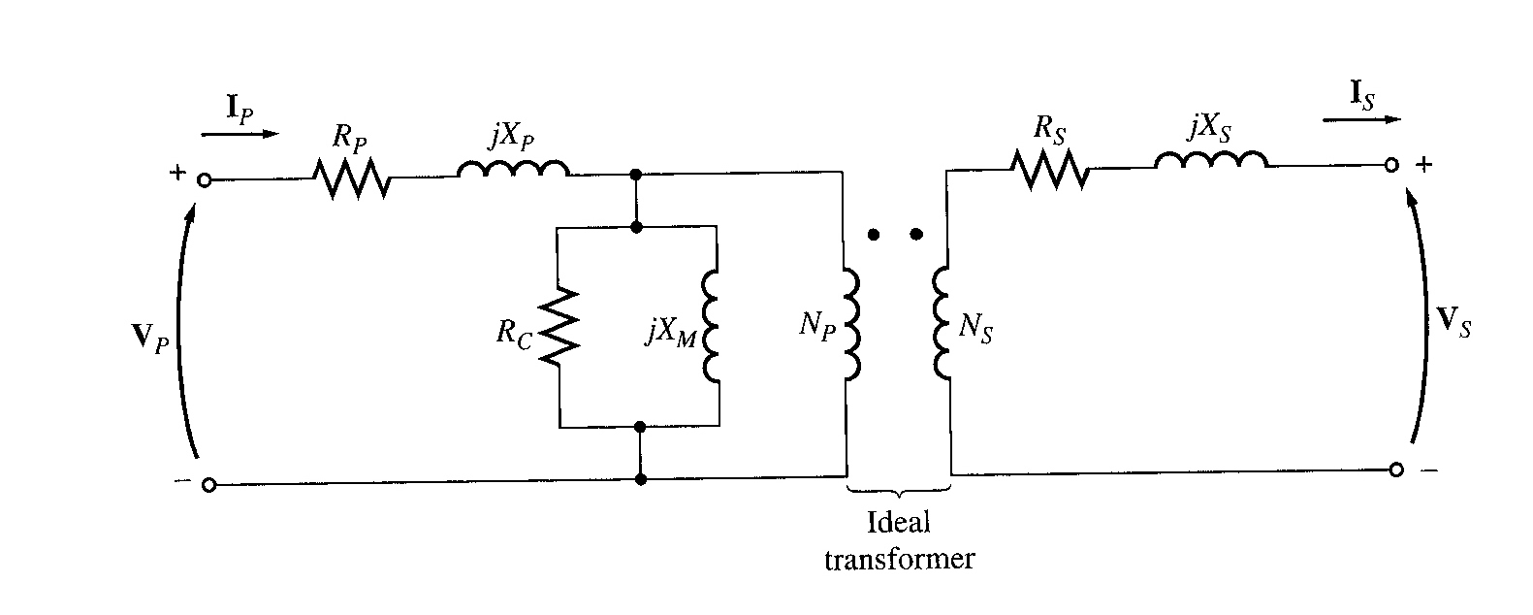
The resulting equivalent circuit:

Based upon the equivalent circuit, in order for mathematical calculation, this transformer equivalent has to be simplified by referring the impedances in the secondary back to the primary or vice versa.
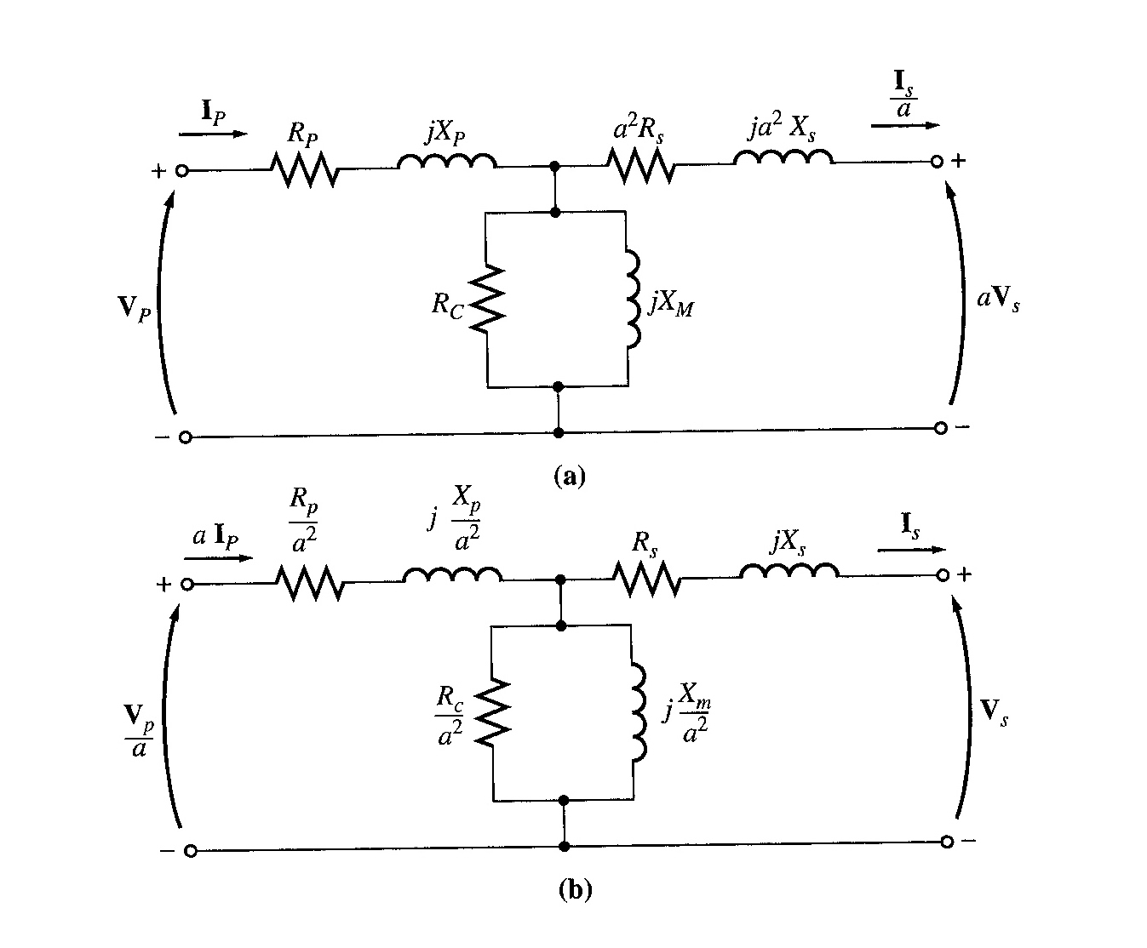

- Equivalent transformer circuit referring to the primary
- Equivalent transformer circuit referring to the secondary

Approximate Equivalent circuits of a Transformer

The derived equivalent circuit is detailed but it is considered to be too complex for practical engineering applications. The main problem in calculations will be the excitation and the eddy current and hysteresis loss representation adds an extra branch in the calculations.

In practical situations, the excitation current will be relatively small as compared to the load current, which makes the resultant voltage drop across Rp and Xp to be very small, hence Rp and Xp may be lumped together with the secondary referred impedances to form and equivalent impedance. In some cases, the excitation current is neglected entirely due to its small magnitude.

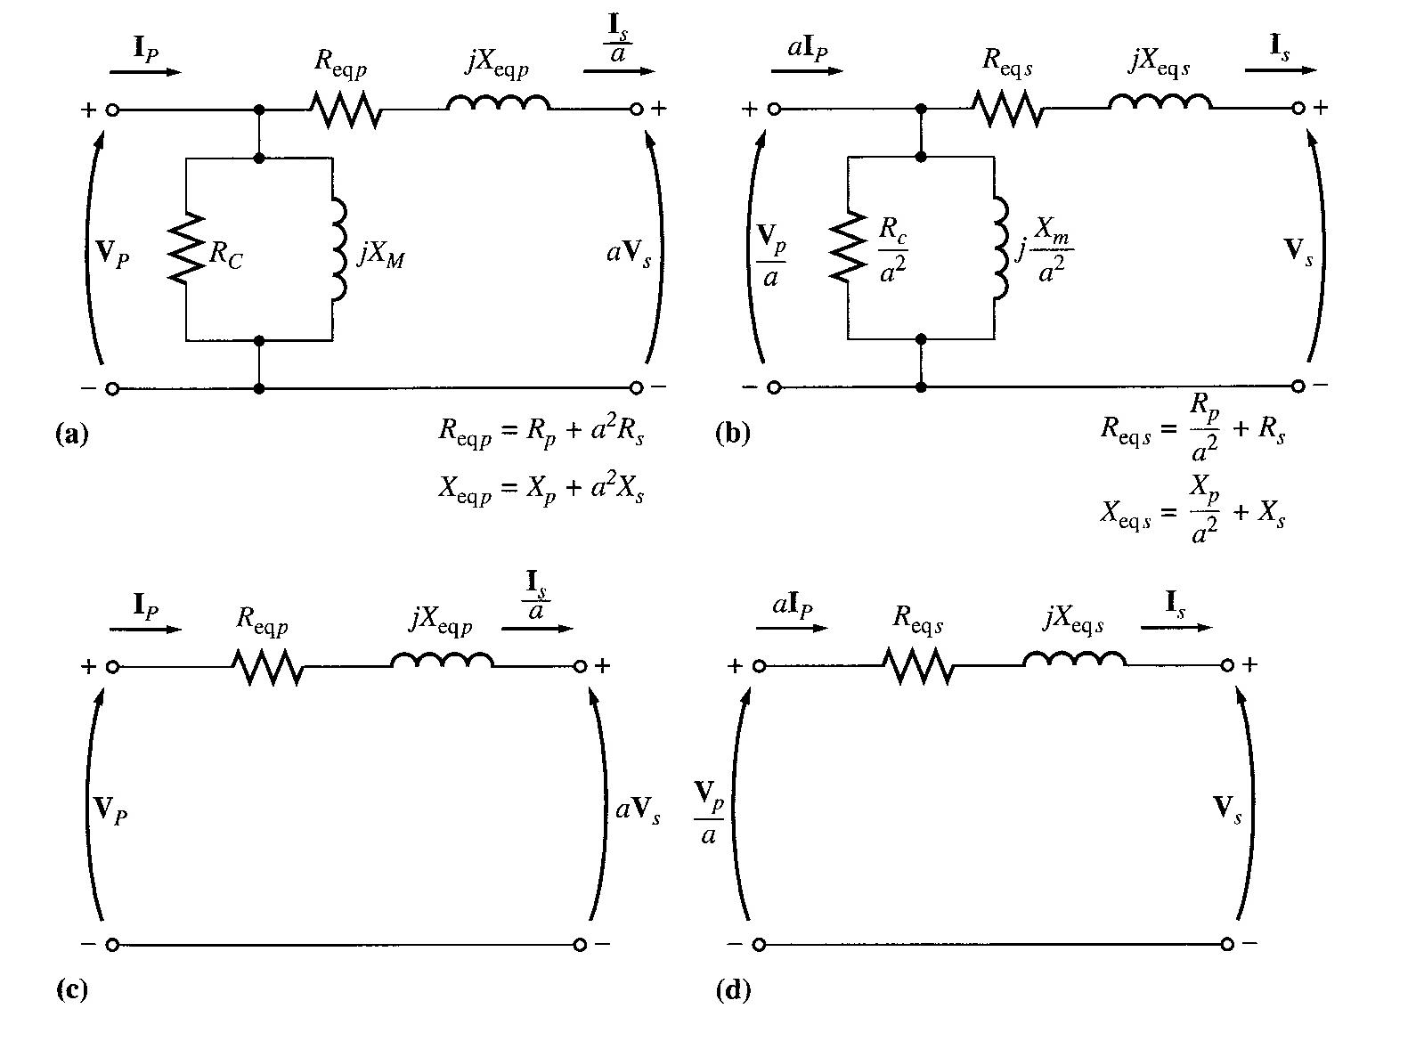

  - Referred to the primary side
  - Referred to the secondary side
  - With no excitation branch, referred to the primary side
  - With no excitation branch, referred to the secondary side

Determining the values of Components in the Transformer Model

The values of the inductances and resistances in the transformer model can be determined experimentally. An adequate approximation of these values can be obtained with the open-circuit test, and the short-circuit test.

Open-circuit Test

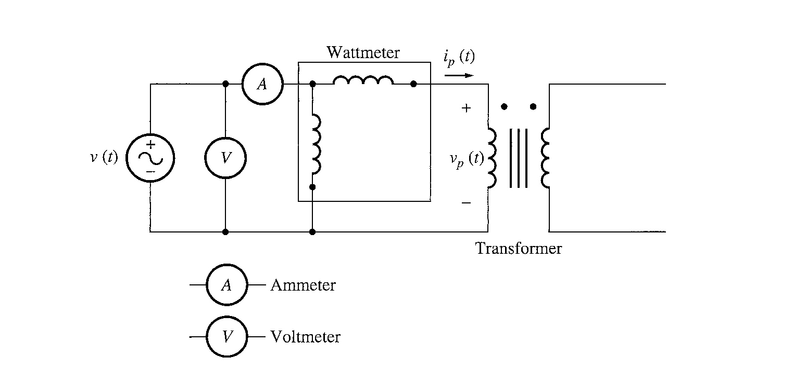
The transformer’s secondary winding is open-circuited, and its primary winding is connected to a full-rated line voltage.

All the input current will be flowing through the excitation branch of the transformer. The series element R_{P} and X_{P} are too small in comparison to R_{C} and X_{M} to cause a significant voltage drop. Essentially all input voltage is dropped across the excitation branch.

Full line voltage is applied to the primary – input voltage, input current, input power measured.
Then, power factor of the input current and magnitude and angle of the excitation impedance can be calculated.

To obtain the values of R_{C} and X_{M} , the easiest way is to find the admittance of the branch.

Conductance of the core loss resistor, G_{c =} 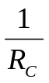

Susceptance of the magnetizing inductor, B_{M =} 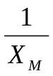

These two elements are in parallel, thus their admittances add.

Total excitation admittance, Y_{E} = G_{C} - jB_{M}
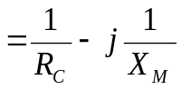

The magnitude of the excitation admittance (referred to primary),
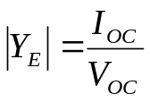

The angle of the admittance can be found from the circuit power factor.

PF = cos θ = 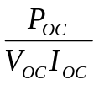
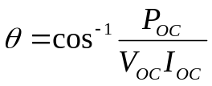

The power factor is always lagging for a real transformer. Hence,
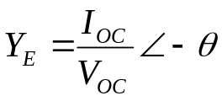

This equation can be written in the complex number form and hence the values of R_{C} and X_{M} can be determined from the open circuit test data.

Short-circuit Test
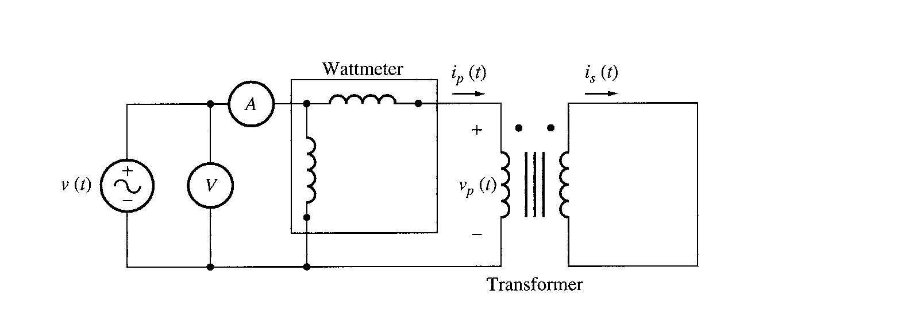
The secondary terminals are short circuited, and the primary terminals are connected to a fairly low-voltage source.

The input voltage is adjusted until the current in the short circuited windings is equal to its rated value. The input voltage, current and power are measured.

The excitation branch is ignored, because negligible current flows through it due to low input voltage during this test. Thus, the magnitude of the series impedances referred to the primary is:
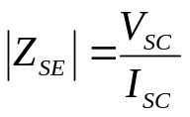

Power factor, PF = cos θ = P_{SC} / V_{SC} I_{SC} (lagging)

Therefore,
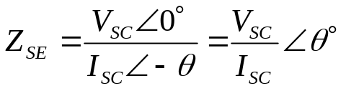

The series impedance Z_{SE} = R_{eq} + jX_{eq}
= (R_{P} + a² R_{S}) + j(X_{P} + a² X_{S})

Example 2.2

The equivalent circuit impedances of a 20kVA, 8000/240V, 60Hz transformer are to be determined. The open circuit test and the short circuit test were performed on the primary side of the transformer, and the following data were taken:

Open circuit test (primary) | Short circuit test
V_{OC} = 8000 V | V_{SC} = 489 V
I_{OC} = 0.214 A | I_{SC} = 2.5 A
P_{OC} = 400 W | P_{SC} = 240 W

Find the impedance of the approximate equivalent circuit referred to the primary side, and sketch the circuit.

5. The Per-Unit System of Measurements

The process of solving circuits containing transformers using the referring method where all the different voltage levels on different sides of the transformers are referred to a common level, can be quite tedious.

The Per-unit System of measurements eliminates this problem. The required conversions are handled automatically by the method.

In per-unit system, each electrical quantity is measured as a decimal fraction of some base level. Any quantity can be expressed on a per-unit basis by the equation
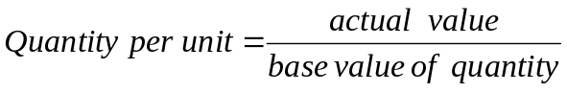

Two base quantities are selected to define a given per-unit system. The ones usually selected are voltage and power. In a single phase system, the relationship are:

P_{base}, Q_{base} or S_{base} = V_{base} I_{base}

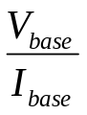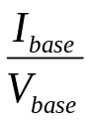
Z_{base} = Y_{base} =

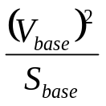
And Z_{base} =

All other values can be computed once the base values of S (or P) and V have been selected.

In a power system, a base apparent power and voltage are selected at a specified point in the system. A transformer has no effect on the base apparent power of the system, since the apparent power equals the apparent power out.

Voltage changes as it goes through a transformer, so V_{base} changes at every transformer in the system according to its turns ratio. Thus, the process of referring quantities to a common level is automatically taken care of.

Example 2.3

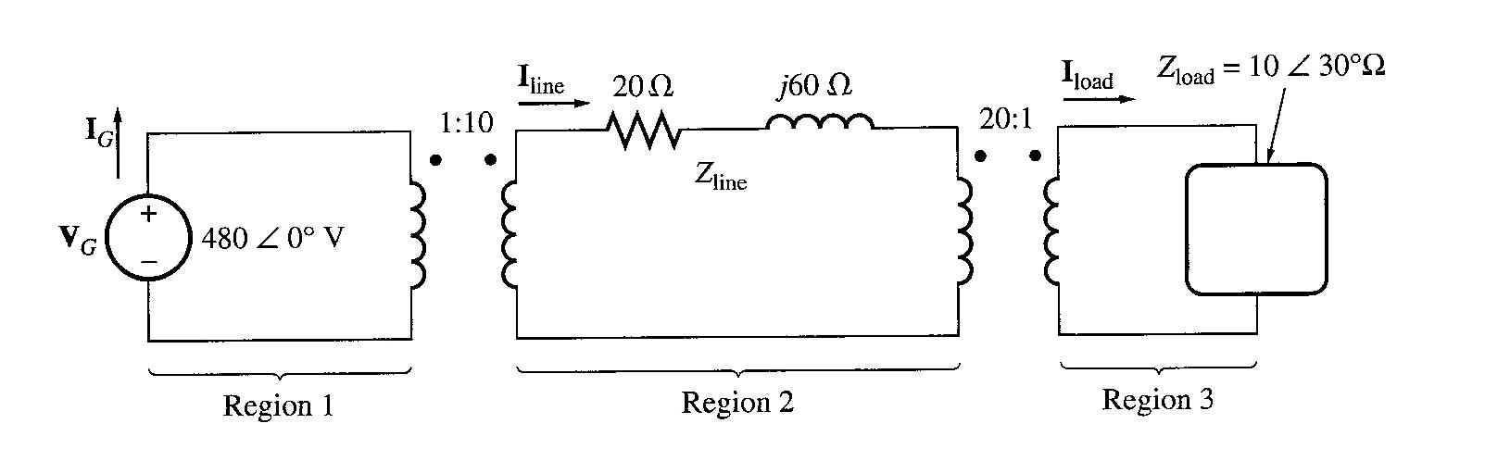
A simple power system is shown below. This system contains a 480V generator connected to an ideal 1:10 step-up transformer, a transmission line, an ideal 20:1 step-down transformer, and a load. The impedance of the transmission line is 20 + j60Ω, and the impedance of the load is 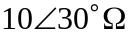. The base values for this system are chosen to be 480V and 10kVA at the generator.

      - Find the base voltage, current, impedance, and apparent power at every point in the power system.
      - Convert this system to its per-unit equivalent circuit.
      - Find the power supplied to the load in this system.
      - Find the power lost in the transmission line.

6. Transformer Voltage Regulation and Efficiency

The output voltage of a transformer varies with the load even if the input voltage remains constant. This is because a real transformer has series impedance within it. Full load Voltage Regulation is a quantity that compares the output voltage at no load with the output voltage at full load, defined by this equation:
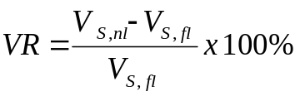

At no load, V_{S} = V_{P}/a thus,
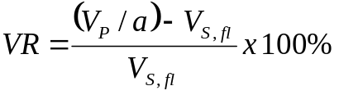

In per-unit system,
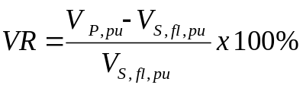

Ideal transformer, VR = 0%.

The transformer phasor diagram

To determine the voltage regulation of a transformer, we must understand the voltage drops within it.

Consider the simplified equivalent circuit referred to the secondary side:
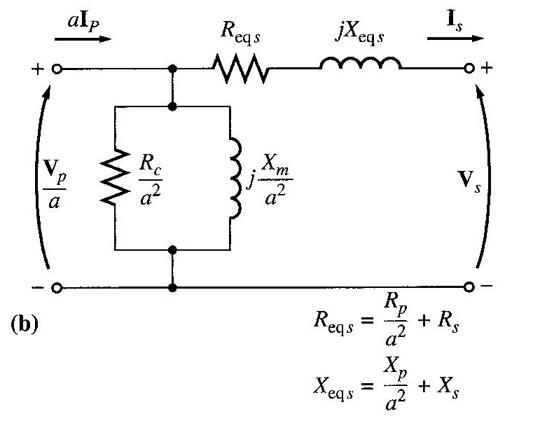

Ignoring the excitation of the branch (since the current flow through the branch is considered to be small), more consideration is given to the series impedances (Req +jXeq). Voltage Regulation depends on magnitude of the series impedance and the phase angle of the current flowing through the transformer. Phasor diagrams will determine the effects of these factors on the voltage regulation. A phasor diagram consist of current and voltage vectors.

Assume that the reference phasor is the secondary voltage, V_{S}. Therefore the reference phasor will have 0 degrees in terms of angle.

Based upon the equivalent circuit, apply Kirchoff Voltage Law,
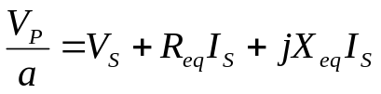

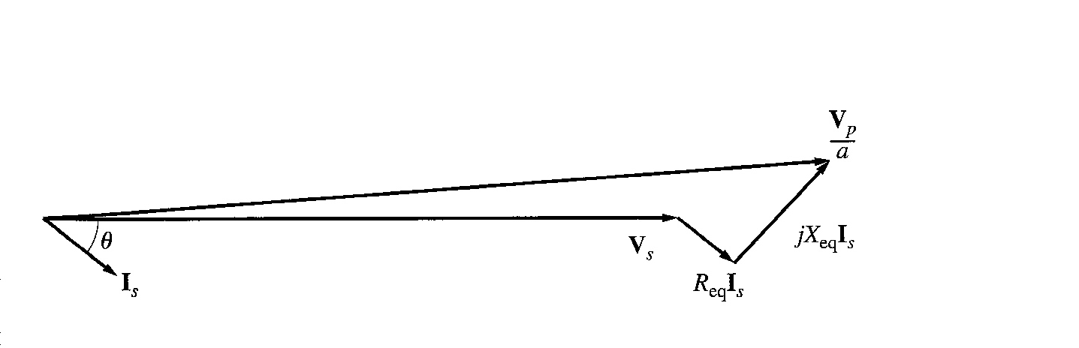
From this equation, the phasor diagram can be visualised.

Figure below shows a phasor diagram of a transformer operating at a lagging power factor. For lagging loads, V_{P} / a > V_{S} so the voltage regulation with lagging loads is > 0.

At lagging power factor

When the power factor is unity, V_{S} is lower than V_{P} so VR > 0. But, VR is smaller than before (during lagging PF).
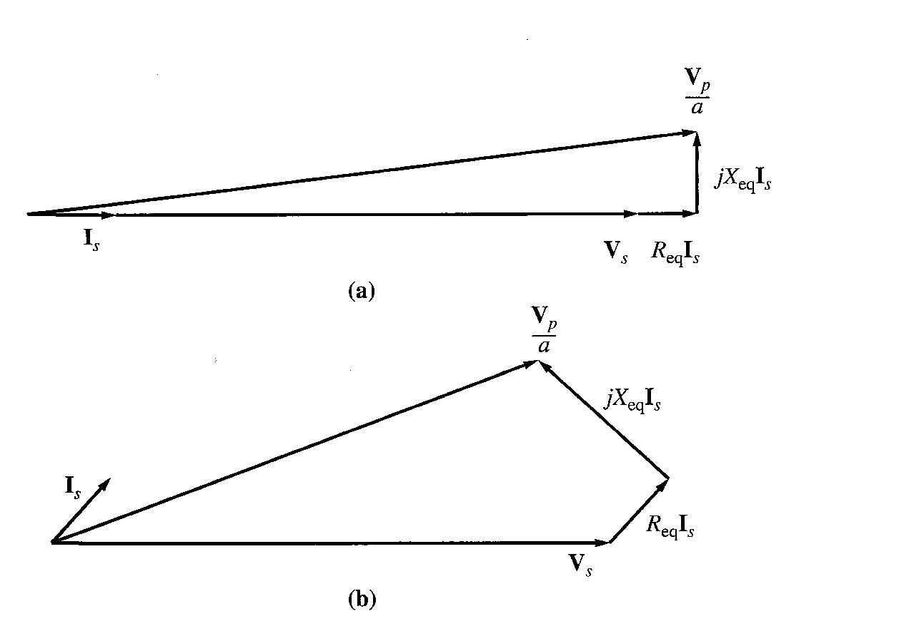
With a leading power factor, V_{S} is higher than the referred V_{P} so VR < 0.

Unity PF

Leading PF

In summary:

Lagging PF | V_{P} / a > V_{S} | VR > 0
Unity PF | V_{P} / a > V_{S} | VR > 0 (smaller than VR lag)
Leading PF | V_{S} > V_{P} / a | VR < 0

Due to the fact that transformer is usually operated at lagging pf, hence there is an approximate method to simplify calculations.

Simplified Voltage Regulation Calculation

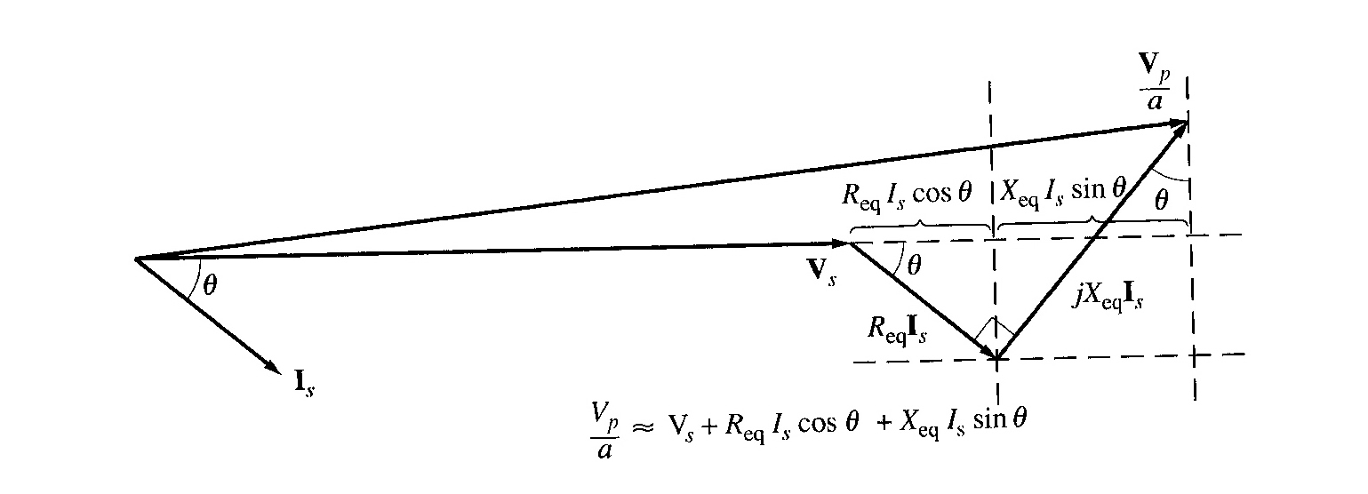
For lagging loads, the vertical components of R_{eq} and X_{eq} will partially cancel each other. Due to that, the angle of V_{P}/a will be very small, hence we can assume that V_{P}/a is horizontal. Therefore the approximation will be as follows:

Transformer Efficiency

Transformer efficiency is defined as (applies to motors, generators and transformers):
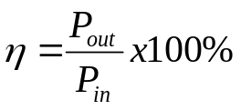

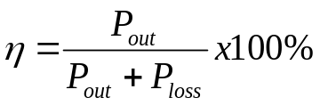

Types of losses incurred in a transformer:

- Copper I²R losses
- Hysteresis losses
- Eddy current losses

Therefore, for a transformer, efficiency may be calculated using the following:
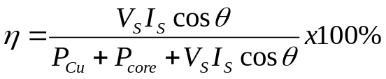

Example 2.5

A 15kVA, 2300/230 V transformer is to be tested to determine its excitation branch components, its series impedances, and its voltage regulation. The following data have been taken from the primary side of the transformer:

Open circuit test | Short-circuit test
V_{OC}= 2300V | V_{SC}= 47V
I_{OC}= 0.21A | I_{SC}= 6A
P_{OC}= 50W | P_{SC}= 160W

  - Find the equivalent circuit referred to the high voltage side
  - Find the equivalent circuit referred to the low voltage side
  - Calculate the full-load voltage regulation at 0.8 lagging PF, 1.0 PF, and at 0.8 leading PF.
  - Find the efficiency at full load with PF 0.8 lagging.

7. Three phase Transformers

Transformers for 3-phase circuits can be constructed in two ways:
  - connect 3 single phase transformers
  - Three sets of windings wrapped around a common core.

Three-Phase Transformer Connections

The primaries and secondaries of any three-phase transformer can be independently connected in either a wye (Y) or a delta (∆).

The important point to note when analyzing any 3-phase transformer is to look at a single transformer in the bank. Any single phase transformer in the bank behaves exactly like the single-phase transformers already studied.

The impedance, voltage regulation, efficiency, and similar calculations for three phase transformers are done on a per-phase basis, using same techniques as single-phase transformers.

A simple concept that all students must remember is that, for a Delta configuration,
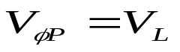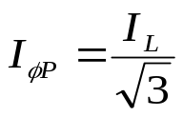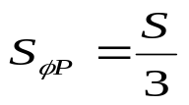

For Wye configuration,
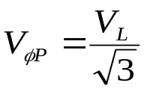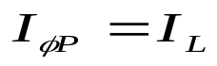

Calculating 3 phase transformer turns ratio

The basic concept of calculating the turns ratio for a single phase transformer is utilised where,
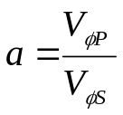

Therefore to cater for 3 phase transformer, suitable conversion into per phase is needed to relate the turns ratio of the transformer with the line voltages.

The Per-unit System for 3-Phase Transformer

The per unit system of measurements application for 3-phase is the same as in single phase transformers. The single-phase base equations apply to 3-phase on a per-phase basis.

Say the total base voltampere value of a transformer bank is called S_{base}, then the base voltampere value of one of the transformer is
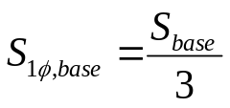

And the base current and impedance are
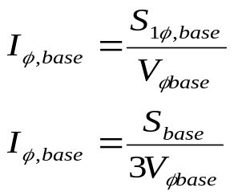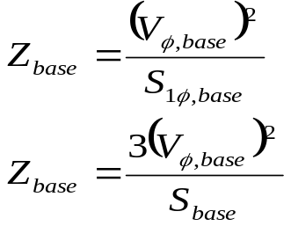

Example 2.9

A 50-kVA 13,800/208-V ∆-Y distribution transformer has a resistance of 1% and a reactance of 7% per unit.

  - What is the transformer’s phase impedance referred to the high voltage side?
  - Calculate this transformer’s voltage regulation at full load and 0.8PF lagging, using the calculated high side impedance.
  - Calculate this transformer’s voltage regulation under the same conditions, using the per-unit system.

